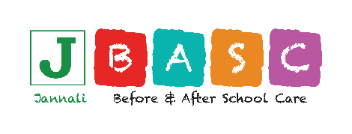 Spring Vacation Care 2023
Booking Form for Existing Families
Please book my child/ren for the date/s ticked below
Children are not to come to the centre if they are unwell. If a child becomes unwell, parents will be contacted to collect their child immediately.
Child/ren’s Name and Age:
Parent/Guardian Name:
Phone/Mobile:
Work Phone Number:
Parent/Guardian Email

All inhouse, Excursion and Incursion bookings/permission to be returned by Friday the 15th of September. Bookings subject to availability after this date.
Week 1
Daily Fee: $67.00 | Program Cost | Program  Excursion / Incursion / In House | Child/ren  Attending
Monday 25th |  | Comic Book Day
Tuesday 26th | $36 | Fringe Festival ‘101 to Annoy Your Parents’
Wednesday 27th |  | SGSCC College Visit
Thursday 28th |  | JBASC Slumber Party
Friday 29th | $15 | Something Wild
Week 2
Daily Fee: $67.00 | Program Cost | Program  Excursion / Incursion /In House | Children  Attending
Monday 2nd |  | Public Holiday
Tuesday 3rd | $32 | Movies
Wednesday 4th |  | Spring Fair
Thursday 5th | $15 | Stars and Sounds
Friday 6th |  | Mad Hatter Tea Party

Parent/Guardian Signature:
I Parent / Guardian give permission for my child
To be engaged in the above activities at Jannali Vacation Care.

